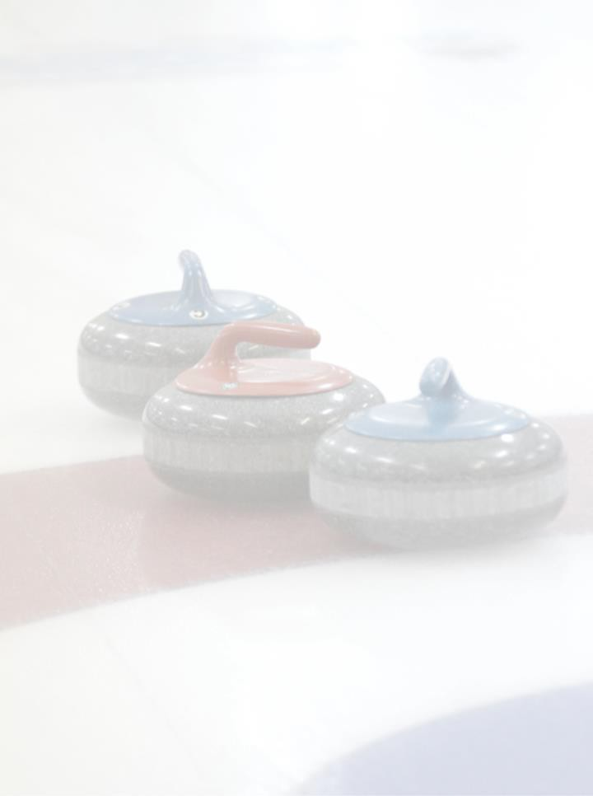
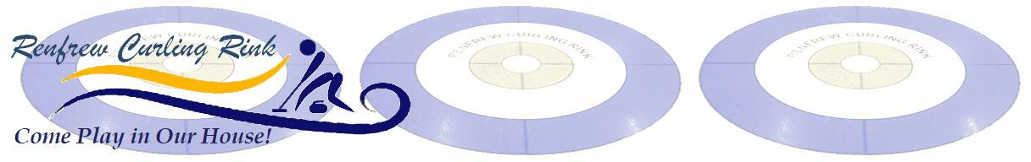
9th ANNUAL OPEN CASHSPIEL

Saturday November 22, 2025
Opening Draws at 8:00 & 10:00 am

Sponsored By:

PROGRESSIVE CASH DRAW—THREE 6-END GAMES
ENTRY FEE - $360 (Incl. Continental, Lunch, Dinner & Cash Prizes)
A and B Draw Winners: Game 1 - $50
Game 2 - $100 Game 3 - $200
Send registration & cheque payable to address below
We do accept e-Tranfers, direct deposit to renfrewcurling@gmail.com
Renfrew Curling Rink 195 Xavier St.Renfrew On K7V 1L3
For more information Phil, Dave or Larry at bonspiels@renfrewcurling.ca

Name
Address
Phone # |  | Email
Team | Skip | Third |  | Second |  | Lead
Preferred Draw |  | 8:30 |  |  | 10:00

