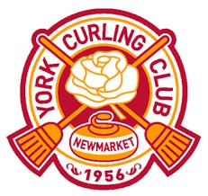
IS PROUD TO PRESENT THE ANNUAL

OPEN BONSPIEL

Saturday November 1st, 2025

Entry Fee: $360 per team
Want $40 off? Enter ‘HoY2025’ discount code (expires October 2nd)
- 24 Team “Point Spiel” with 2 draws (registration 8am or 9:45am)
- 3 Games Guaranteed: 2 6-end (time clock used) and 1 8-end
- Delicious meals: Eye Openers, Lunch and Prime Rib Dinner
- Team Door Prizes, 50/50 Draw, Game Prizes and of course, Cash Prizes for draw winners

Click here to Register

Have questions? Don’t hesitate to reach out!!
Event Coordinator: Vicki Greenwood greenwoodvj@gmail.com

